**Practical No.8**

**AIM**: Write a program for web feed.

THEORY: RSS builder allows you to create a feed from specific sections of the webpage. You can generate a feed using RSS builder in two modes: **Quick mode**and**Advanced mode.**

An RSS feed is a feed that delivers **auto-updated** content to users without having to manually go to a specific website. It is formatted into an XML file that can be read in an RSS reader or embedded into your website.

**IMPLEMENTATION:**

Step 01: Open RSS builder

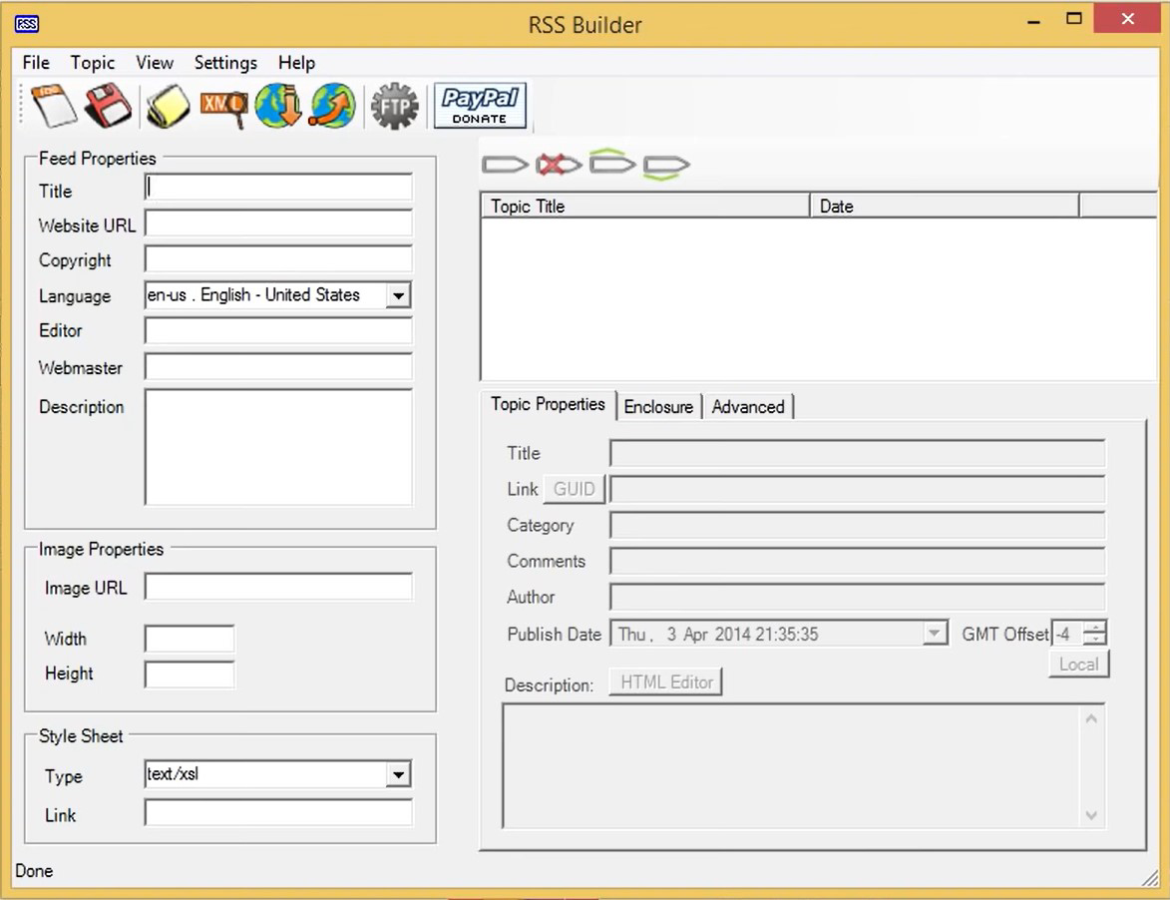

Step 02: Fill the Feed properties 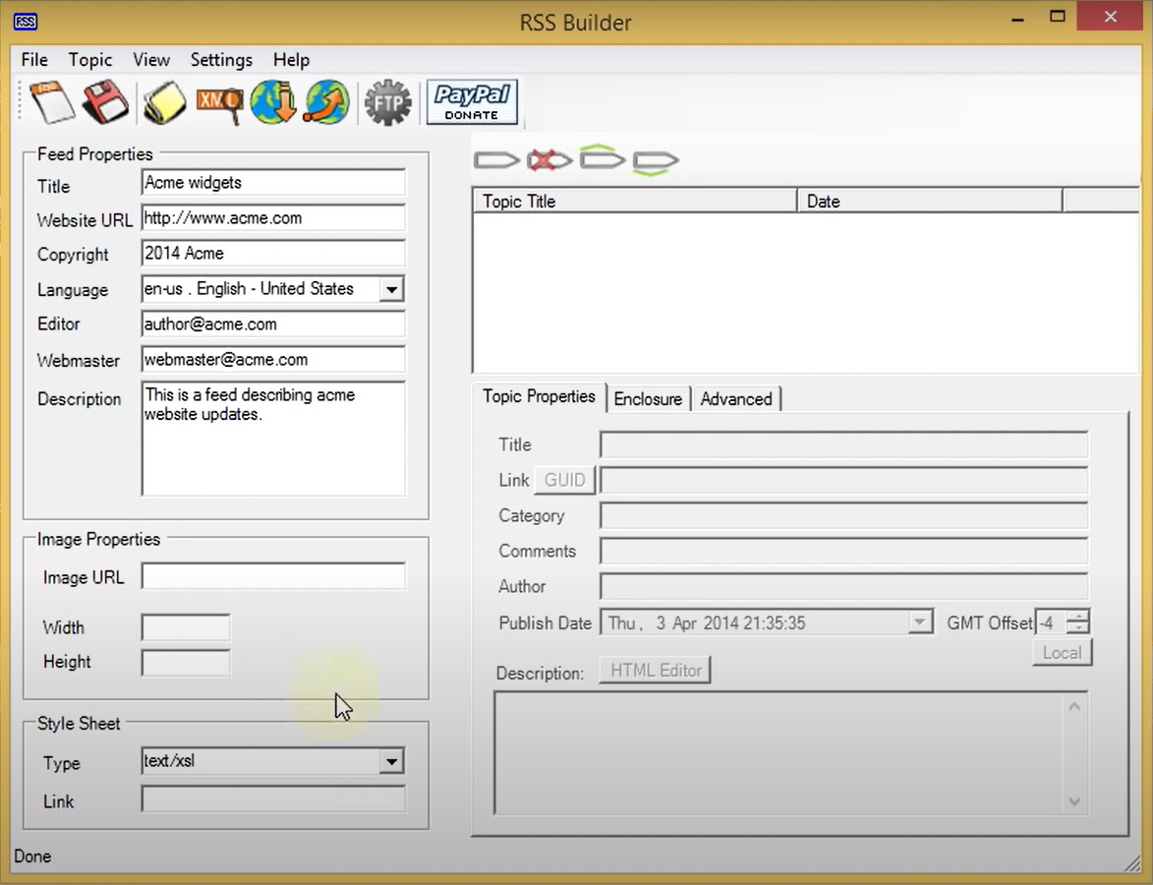

Step 03: Click on Add a Topic to add new topic to your feed

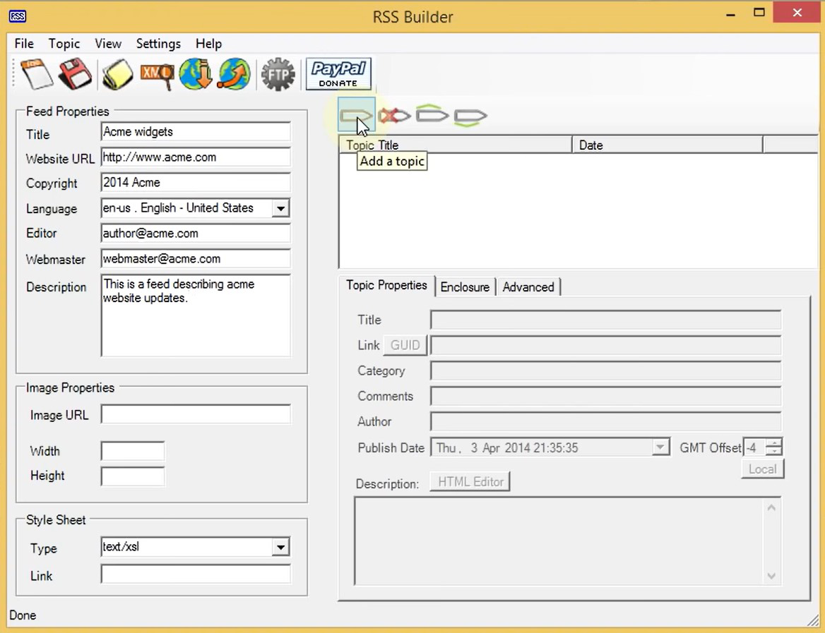

Step 04: Fill the topic properties

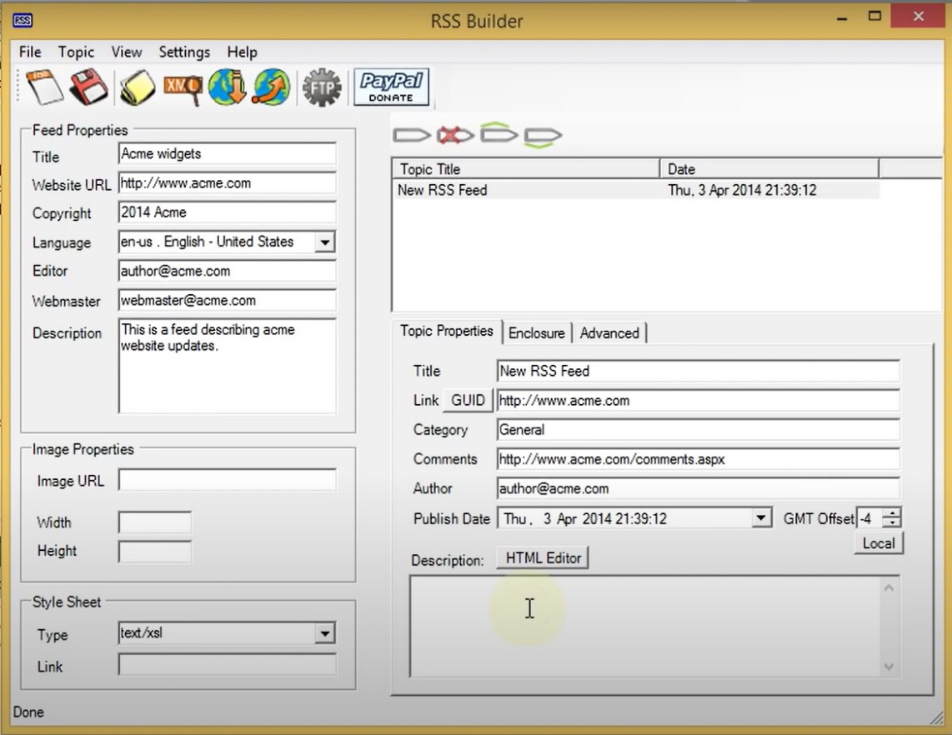

Step 05:To add description on web feed click on HTML editor

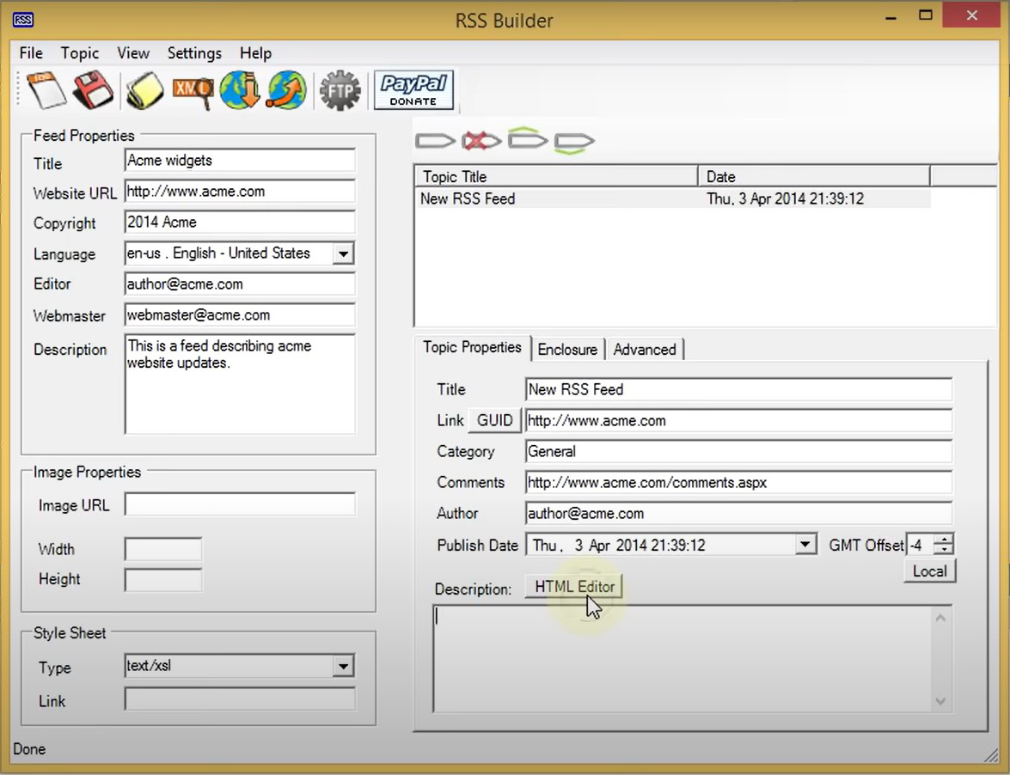

Step 06:Add topic description to show in feed

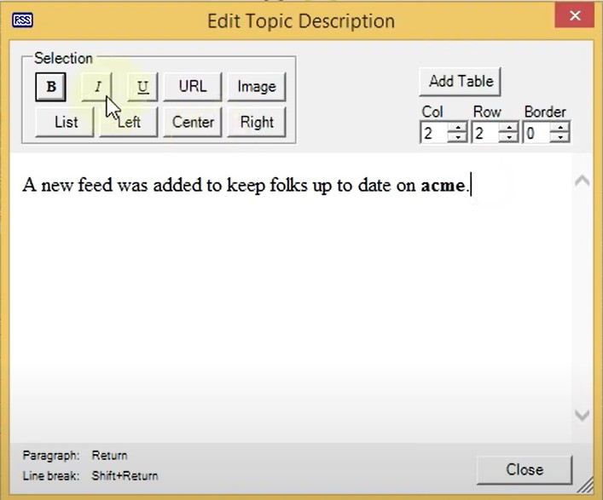

Step 07:Save the feed in xml format(defaultly saved in .xml)

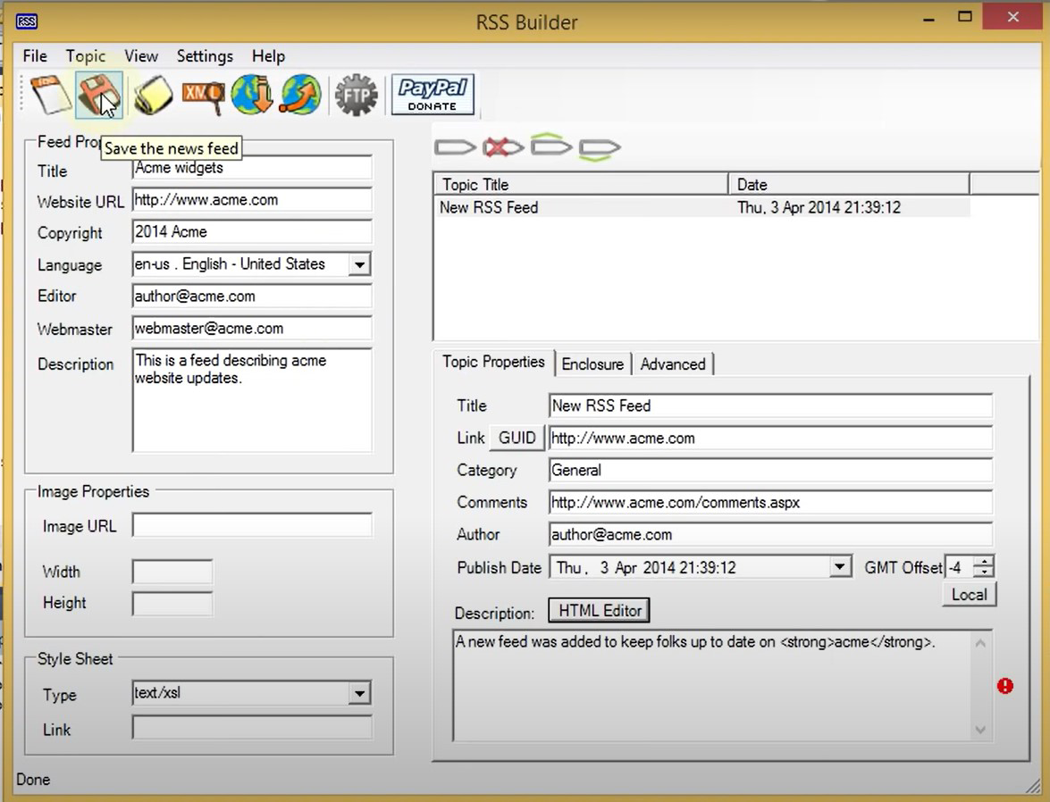

Step 08:launch Visual Studios 2010 to launch the sample website

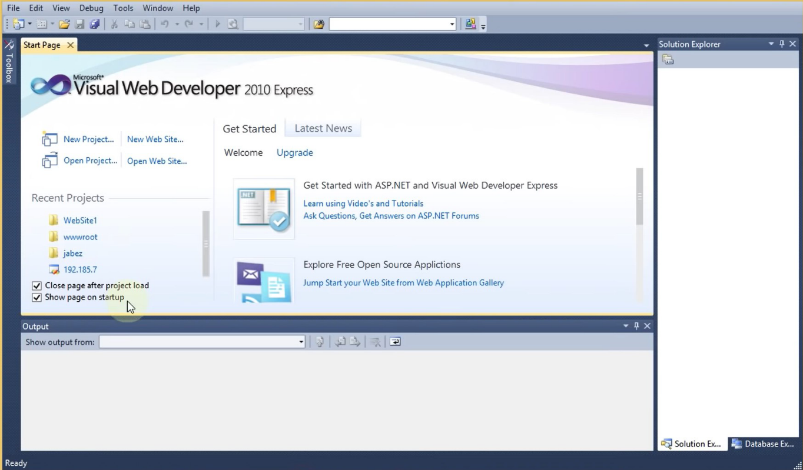

Step 09:Create new website on asp.net web site

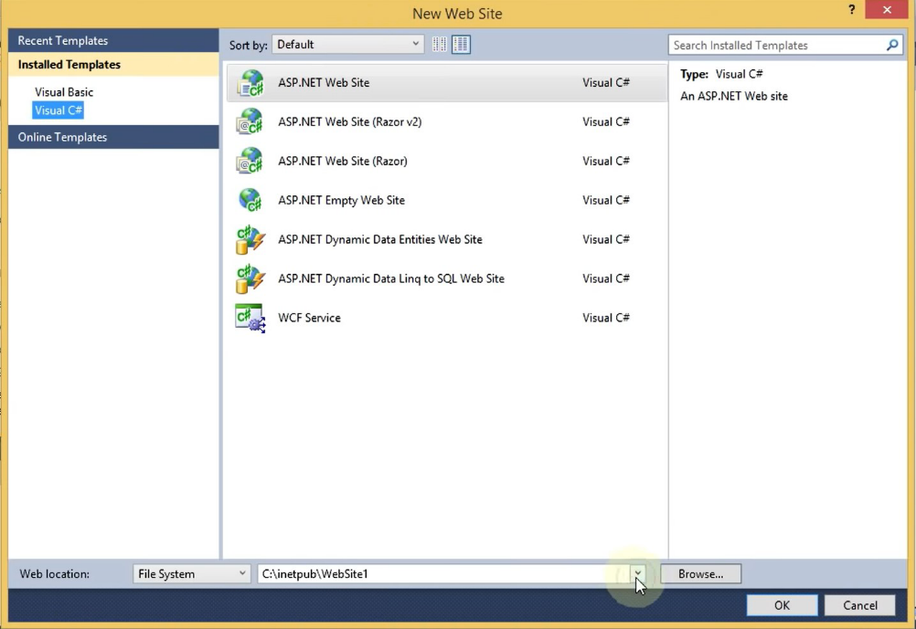

Step 10:Add new paragraph in default.aspx file and provide a link to server to access your website

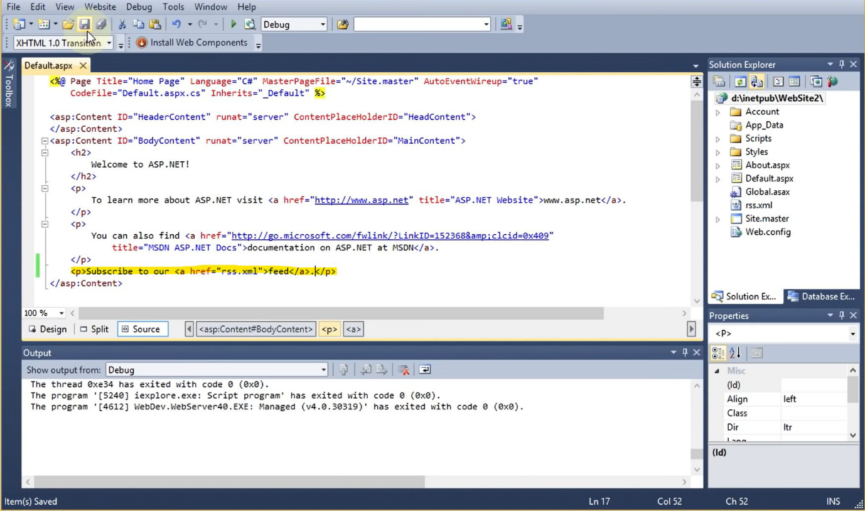

Step 11:Run the program the page will appear as shown in the figure where the given link is provided click on it.

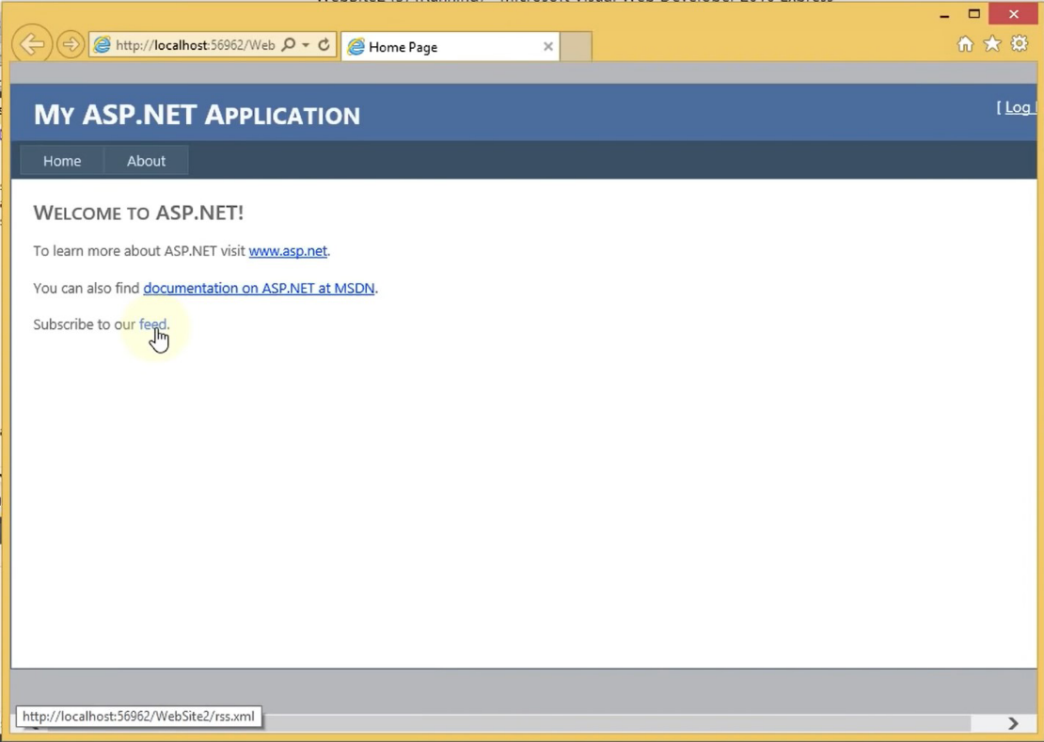

Step 12:New RSS feed will be created after clicking on the link to see the final output.

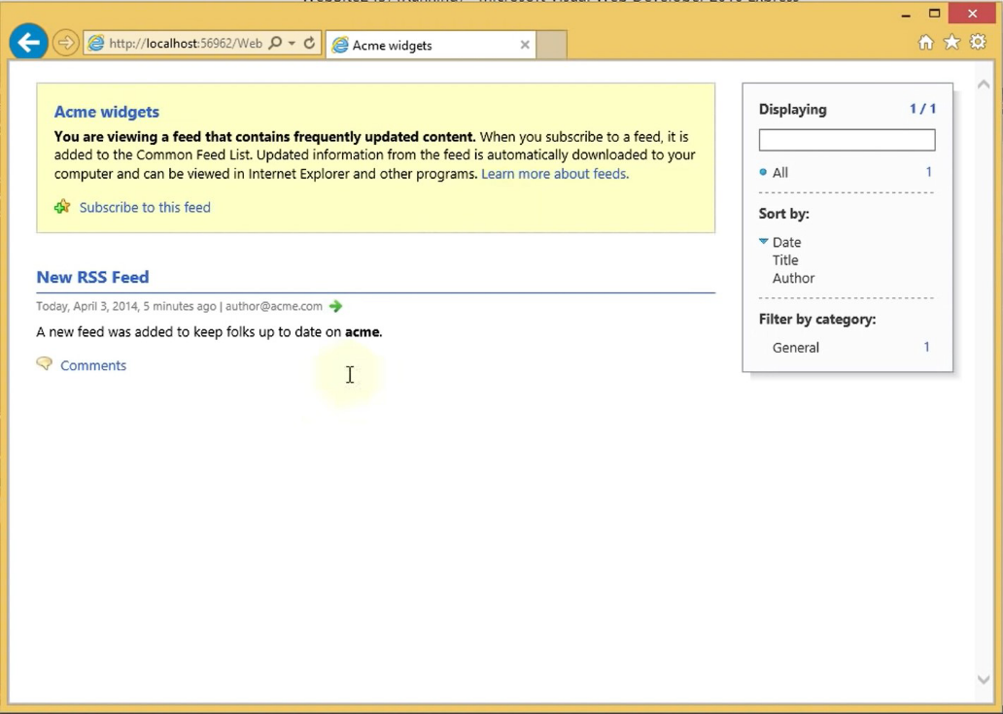

CONCLUSION :Successfully Performed, Your feed is now ready to be embedded and shared.